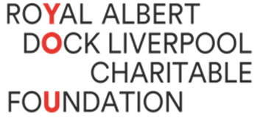
Social Media Volunteer/ Work Experience Volunteer

The Role
The Social Media Volunteer will work with the Royal Albert Dock Liverpool Charitable Foundation to help them maintain and expand their online presence. The role will include office work and site visits under the supervision of the charity’s Operations Manager. The role will be one day a week for an agreed number of weeks with the volunteer.
Duties
- To create content for the Foundation’s already established social media channels including Instagram, Facebook, Twitter, and LinkedIn. This could include photographic, video, or written content following the tone already set for each channel.
- Edit video content into shorter videos for use on social media.
- To come up with ideas for new content based on their experiences of the charity.
- To come up with ideas for the charity’s TikTok and YouTube accounts that we are yet to launch.
Skills
- A desire to help a small charity reach more people that they can offer their services to (Essential)
- Experience of using social media (including just your own personal accounts) (Essential)
- Experience of creating content for a social media platform (Desirable)
- Experience with editing videos (Desirable)

